Use of Templates for entity types of Property

We are mostly familiar with the use of properties using entities of type SinglePropertyDimension and there are established templates for their use.
There are additionally templates for entities of type Property which have caused some confusion and I have asked by the IIP to clarify the usage of the associated templates
The version for Whole Life Individual has this graph

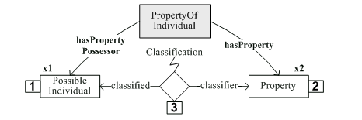
With the signature
Role No | Role Name | Role Object Type | Remarks and Examples
1 | hasPropertyPossessor | dm:PossibleIndividual
2 | hasProperty | dm:Property | Use ID from RDL or elsewhere

Given the example of Stream S34 with a temperature of 100 C It is my understanding that the Instantiated Template would look something like this
Role No | Role Name | Role Object Type | Value
1 | hasPropertyPossessor | dm:PossibleIndividual | Uuid of Stream S34
2 | hasProperty | dm:Property | Uuid of Property Definition ‘100 C’ in the RDL or Project Triple Store

The class version – PropertyOfClassOfIndividual has the following graph

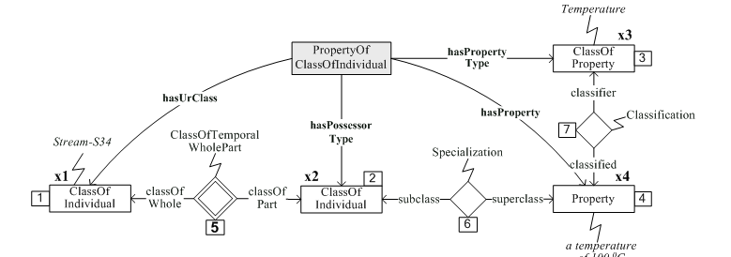
With this signature

Role No | Role Name | Role Object Type | Remarks & Examples
1 | hasUrClass | dm:ClassOfIndividual | ID to be generated automatically
2 | hasPossessorType | dm:ClassOfIndividual | ID to be generated automatically
3 | hasPropertyType | dm:ClassOfProperty | use ID from RDL
4 | hasProperty | dm:Property | use the ID of an already defined Property instance

Given the example values of Stream S34 having a temperature 100 C It is my understanding that the Instantiated Template would look something like this
Role No | Role Name | Role Object Type | Values
1 | hasUrClass | dm:ClassOfIndividual | uuid of UrClass for Stream S34
2 | hasPossessorType | dm:ClassOfIndividual | uuid of Template Instance
3 | hasPropertyType | dm:ClassOfProperty | uuid of ClassOfProperty in RDL used to group Properties such as BOILING_TEMPERATURE CLASS
4 | hasProperty | dm:Property | uuid of the already defined Property instance 100 C which contains both the value and scale (unit of measurement)

